
Spurcroft Primary School English Progression of knowledge Year 2

Year 2 | Autumn 1  Entertain | Autumn 1  Entertain | Autumn 2  Entertain | Autumn 2  Inform | Spring 1  Entertain | Spring 1  Inform | Spring 2  Entertain | Spring 2  Entertain/Inform | Summer 1  Entertain | Summer 1  Inform | Summer 2  Entertain | Summer 2 Entertain
Purpose and planning | Develop positive attitudes towards and stamina for writing by: writing narratives about personal experiences and those of others (real and fiction), writing about real events, writing poetry, writing for different purposes
Drafting and writing | Consider what they are going to write before beginning by: planning or saying out loud what they are going to write about, writing down ideas and key words including new vocabulary, encapsulating what they want to say sentence by sentence
Evaluating and editing | Make simple additions, revisions and corrections to their own writing by: evaluating their writing with the teacher and other pupils, re-reading to check that their writing makes sense and that verbs to indicate time are used correctly and consistently, including verbs in the continuous form, proof reading to check for errors in spelling, grammar and punctuation (for examples, ends of sentences punctuated accurately.)
Stimulus | Character description  Rainbow fish  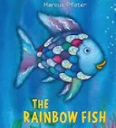 | Narrative  Super tato  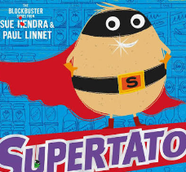 | Poetry  Father Christmas needs a wee  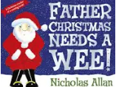 | Letter to Santa  Jolly Postman Christmas  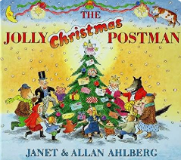 | Description- settings and character  The 3 little wolves and big bad pig  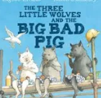 | Recount (trip) Change term to suit. | Narrative  Binny’s Diwali   | Diary- possible link to history?  Look up!  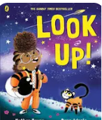  Bob the man on the moon   | Poetry  Michael Rosen poetry videos  Acrostic poem | Instructions to look after a made up animal (science link)  How to…a woolly mammoth  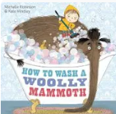 | Narrative  George’s marvellous medicine  - Character description  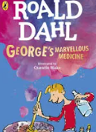 | Narrative  Narrative  George’s marvellous medicine- writing an alternative e.g. Sarah’s amazing potion.
NC objectives | Capital letters and full stops  Conjunctions  Expanded noun phrases | Capital letters and full stops  Commas in a list Present and past tenses | Using “and” to join clauses  Expanded noun phrases | Capital letters and full stops  Expanded noun phrases | Capital letters and full stops  Expanded noun phrases | Using “if” in a sentence  Verbs  Subordinating and coordinating conjunctions  To use “or”  Questions and question marks  Commands | Exclamation marks  Question marks  Conjunctions “when” “because” “also” “so” “but”  Noun phrase | Using “and” to join clauses  Verbs  Subordinating and coordinating conjunctions | Expanded noun phrases | Apostrophes for possession  Questions and question marks  Subordination | Expanded noun phrases  Apostrophes for possession | Expanded noun phrases  Apostrophes for possession  Conjunctions “when” “because” “also” “so” “but”

