
Spurcroft Primary School English Progression of knowledge Years 3 /4
Cycle A- 2026/2027

Years 3/4 | Autumn 1  Entertain |  | Autumn 1  Entertain | Autumn 2  Inform | Autumn 2  Persuade | Spring 1  Entertain | Spring 1  Entertain/inform | Spring 2  Inform | Spring 2  Persuade | Summer 1  Inform | Summer 1  Inform | Summer 2  Entertain | Summer 2  Entertain
Purpose and planning
  Plan their writing by:
  • discussing writing similar to that which they are planning to write in order to understand and learn from its structure,
  vocabulary and grammar
  • discussing and recording ideas
Drafting and writing
  Draft and write by:
  • composing and rehearsing sentences orally (including dialogue), progressively building a varied and rich vocabulary and an
  increasing range of
  sentence structures (English Appendix 2)
  • organising paragraphs around a theme
  • in narratives, creating settings, characters and plot
  • in non-narrative material, using simple organisational devices [for example, headings and sub-headings]
Evaluating and editing
  Evaluate and edit by:
  • assessing the effectiveness of their own and others’ writing and suggesting improvements
  • proposing changes to grammar and vocabulary to improve consistency, including the accurate use of pronouns in sentences
  Proof-read for spelling
Stimulus | Narrative  The Magic Paintbrush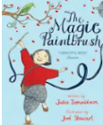 |  | Poetry  Kapok tree   | Non chronological report based on curriculum  The street beneath my feet  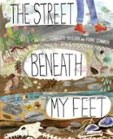 | Persuade  Protect the planet by Jess French   | Narrative  Journey  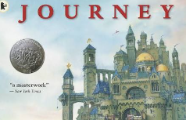 |   Diary  Poetry-  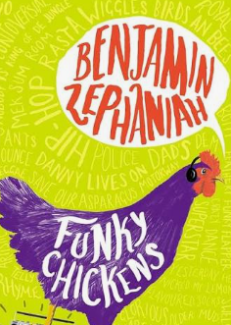  Benjamin Zephaniah  performance week | Instructions Roman linked e.g. battle formation/ shield | The true story of the three little pigs  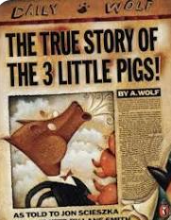  Persuade/points of view | Summer 1  Recount of trip or experience | NCR-topic based | Poetry- possibly linked to book  In next column | Narrative  Arthur and the golden rope  
Year 3  NC OBJECTIVES | Dialogue- begin to use inverted commas  Prepositions  Alliteration  Time adverbials  Adverbs and verbs  Noun phrases  Complex sentences-conjunctions  Third person |  | Expanded noun phrases  Specific verbs  Adverbs | Use conjunctions, adverbs and prepositions to express time, place and cause  Questions  Conjunctions  Headings  Grouping related material in to  paragraphs  Present or past tense  A or an | Use conjunctions, adverbs and prepositions to express time, place and cause  Present perfect  Paragraphs  Expanded noun phrases | Dialogue- begin to use inverted commas  Prepositions  Alliteration  Time adverbials  Adverbs and verbs  Noun phrases  Complex sentences-conjunctions  Third person | Time adverbials  Expanded noun phrases  Specific verbs  Adverbs  Questions  Present or past tense | Expanded noun phrases  Specific verbs  Adverbs | Use conjunctions, adverbs and prepositions to express time, place and cause  Expanded noun phrases  Specific verbs  Adverbs  Questions  Present or past tense | Time adverbials  Expanded noun phrases  Specific verbs  Adverbs | Headings  Grouping related material in to paragraphs  Expanded noun phrases  Specific verbs  Adverbs  Prepositions | Expanded noun phrases  Alliteration | Dialogue- begin to use inverted commas  Prepositions  Alliteration  Time adverbials  Adverbs and verbs  Noun phrases  Complex sentences- conjunctions  Third person
Year 4  NC OBJECTIVES | Dialogue- accurately punctuated speech  Prepositions  Apostrophes-possessive  Alliteration  Commas used after fronted adverbials  Adverbs  Noun phrases  Complex sentences  Standard English- were not was  Third person |  | Expanded noun phrases  Specific verbs  Adverbs  Commas used after fronted adverbials | Nouns and pronouns to avoid repetition  Paragraphs to organise ideas  Present or past tense  Commas used after fronted adverbials | Nouns and pronouns to avoid repetition  Adverbials for cause and effect  Paragraphs  Expanded noun phrases  Commas used after fronted adverbials | Dialogue- accurately punctuated speech  Prepositions  Apostrophes-possessive  Alliteration  Commas used after fronted adverbials  Adverbs  Noun phrases  Complex sentences  Standard English- were not was  Third person | Paragraphs  Expanded noun phrases  Commas used after fronted adverbials  Specific verbs  Adverbs  Present or past tense | Paragraphs  Expanded noun phrases  Commas used after fronted adverbials  Specific verbs  Adverbs  Present or past tense  Nouns and pronouns to avoid repetition  Paragraphs to organise ideas | Adverbials for cause and effect  Paragraphs  Expanded noun phrases  Commas used after fronted adverbials | Expanded noun phrases  Commas used after fronted adverbials  Nouns and pronouns to avoid repetition  Paragraphs to organise ideas  Present or past tense | Commas used after fronted adverbials  Adverbs  Noun phrases  Complex sentences  Standard English- were not was  Third person  Paragraphs to organise ideas  Present or past tense | Expanded noun phrases  Alliteration | Dialogue- accurately punctuated speech  Prepositions  Apostrophes-possessive  Alliteration  Commas used after fronted adverbials  Adverbs  Noun phrases  Complex sentences  Standard English- were not was  Third person

