
Spurcroft Primary School English Progression of knowledge Years 5/6
Cycle A- 2026/2027

Years 3/4 | Autumn 1  Entertain  Description |  | Autumn 1  Entertain | Autumn 2  Inform  Biographies | Autumn 2  Entertain  Poetry | Spring 1  Persuade/inform  Formal letter | Spring 1  Entertain | Spring 2  Entertain  Poetry | Spring 2  Discuss  Balanced argument | Summer 1  Inform  NCR | Summer 1  Persuade | Summer 2  Entertain | Summer 2  Entertain
Purpose and planning |  | Plan their writing by: identifying the audience for and purpose of writing, selecting the appropriate form and using other similar writing as models for their own; noting and developing initial ideas, drawing on reading and research where necessary; in writing narratives, considering how authors have developed characters and settings in what pupils have read, listened to, seen or performed.
Drafting and writing |  | Draft and write by: selecting appropriate grammar and vocabulary, understanding how such choices can change and enhance meaning; in narratives describe setting, characters and atmosphere and integrating dialogue to convey character and advance the action, using a wide range of devices to build cohesions within and across paragraphs; using further organisational devices to structure text and to guide the reader (headings, bullet points, underlining)
Evaluating and editing |  | Evaluate and edit by: assessing the effectiveness of own and others’ writing, proposing changes to vocabulary, grammar and punctuation to enhance effects and clarify meaning, ensuring the consistent and correct use of tense throughout a piece of writing, ensuring correct subject and verb agreement when using singular and plural, distinguishing between the language of speech and writing and choosing the appropriate register, proof read for spelling and punctuation errors.
Stimulus | Tuesday-narrative, write the story  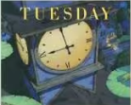 |  | The piano-flashback  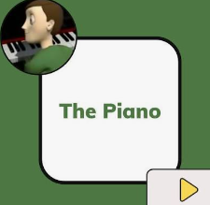 | Write a biography of a fictional character  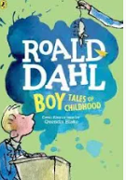 | Jabberwocky by Lewis Carroll  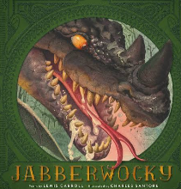 | Letters from the light house  Evacuationletter-formal/  diary  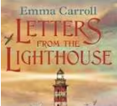 | Clockwork by Phillip Pullman  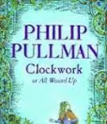 | The Highwayman  Narrative poem   | Zoo-persuasive argument   | Fantastic beasts  NCR  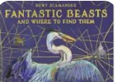 | Choose a relevant topic e.g. Persuade gov to do something/persuade people to recycle etc  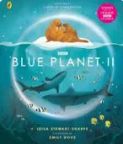 | Francis/  Alma  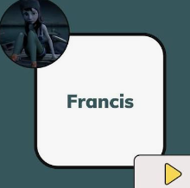 | Rock paper scissors  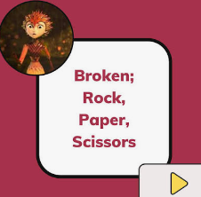
Year 5  NC OBJECTIVES | To describe settings, character and atmosphere  To use dialogue to convey character and advance the action  Write for a range of purposes and audiences  Use range of punctuation taught at KS2 mostly correctly |  | To use dialogue to convey character and advance the action  To describe settings, character and atmosphere | To build cohesion when linking paragraphs e.g. adverbials To use relative clauses  Beginning with a relative pro noun (who, which, where, when, whose, that) | To describe settings, character and atmosphere | To use adverbs and modal verbs to indicate degrees of possibility e.g. should, maybe  To use commas to clarify meaning | To use relative clauses  Beginning with a relative pro noun (who, which, where, when, whose, that)  To use dialogue to convey character and advance the action  To describe settings, character and atmosphere | To describe settings, character and atmosphere  Write for a range of purposes and audiences  Use range of punctuation taught at KS2 mostly correctly | To use brackets, dashes and commas to indicate parenthesis  To use organisational devices that are relevant to the text type e.g. headings and bullet points | To use brackets, dashes and commas to indicate parenthesis  To use organisational devices that are relevant to the text type e.g. headings and bullet points | To use adverbs and modal verbs to indicate degrees of possibility e.g. should, maybe | To describe settings, character and atmosphere  Write for a range of purposes and audiences  Use range of punctuation taught at KS2 mostly correctly | To describe settings, character and atmosphere  Write for a range of purposes and audiences  Use range of punctuation taught at KS2 mostly correctly
Year 6  NC OBJECTIVES | Write for a range of purposes and audiences  Describe settings, character and atmosphere  Dialogue to convey character and advance the action |  | Dialogue to convey character and advance the action  Describe settings, character and atmosphere | Use a range of devices to build cohesion e.g. conjunction, adverbials of time and place etc within and across paragraphs,  Use verb tenses consistently throughout a piece of writing  Exercise an assured and conscious control over levels of formality  Use passive verbs to affect how information is presented | Select language that shows awareness of the reader e.g. first person in a diary | Use a range of devices to build cohesion e.g. conjunction, adverbials of time and place etc within and across paragraphs,  Exercise an assured and conscious control over levels of formality  Use punctuation- hypens, semi colons etc | Use range of punctuation taught at KS2 mostly correctly  Use contracted forms in dialogue  Dialogue to convey character and advance the action  Use punctuation- hypens, semi colons etc | Write for a range of purposes and audiences  Describe settings, character and atmosphere | Use modal verbs to suggest degrees of possibility  Use punctuation- hypens, semi colons etc | Use a range of devices to build cohesion e.g. conjunction, adverbials of time and place etc within and across paragraphs,  Use verb tenses consistently throughout a piece of writing  Exercise an assured and conscious control over levels of formality  Use passive verbs to affect how information is presented | Use modal verbs to suggest degrees of possibility | Write for a range of purposes and audiences  Describe settings, character and atmosphere | Write for a range of purposes and audiences  Describe settings, character and atmosphere

